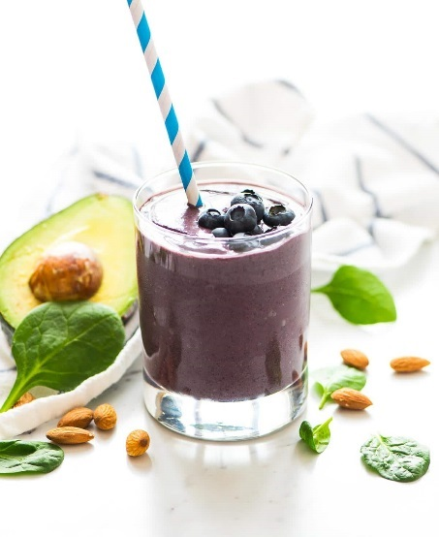
HOW TO MAKE
A HEALTHY SMOOTHIE
Ellen Baxley, RDN itsybitsybites.net

In each smoothie, you want the base to be: 1 cup of fruit, 1-2 cups of veggies, and a protein source. Then you add extra ingredients for added nutrition and taste. Pick from each of the options below to make it easy. Don’t drink the smoothie all at once, drink it throughout the day or over the course of a few hours if possible.

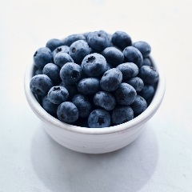
1 cup or 1 small
FRUIT
Berries
Mango
Pineapple
Apple
Banana

Spinach
Kale
Beets (cooked and peeled)
Lettuce (romaine, arugula, etc.)

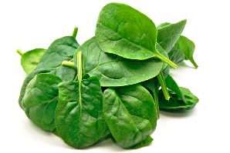
1-2 cups
VEGGIES
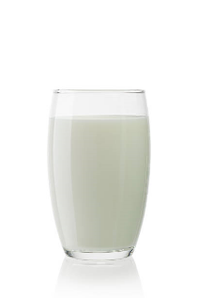
1 tablespoon of any of the following: honey, chia seeds, hemp seeds, flax seed, wheat germ. ½ tsp of: cinnamon, ginger, cocoa powder, vanilla, matcha powder, acai powder
8 oz. low fat organic milk
6oz of plain Greek yogurt
1 scoop organic protein powder
1/3 cup of nuts
1 serving
PROTEIN
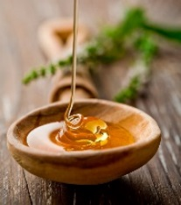
If you want your smoothie thicker you can add ½ avocado, banana or Greek yogurt. If you want it less thick add coconut water, plain water, or milk. See the next page for some tasty recipes
Any from this list
HEALTHY FLAVOR
WEEK ONE
WEEK THREE
Mon-Tues Apple-ginger green juice
2 cups spinach
3 celery
cucumber
ginger
apple

Wed-Thurs Great detoxifier
1 Beet root
1 carrot
1 apple
Juice from ½ lemon

Fri-Sat Confetti Smoothie
1 large handful of kale
1 cup of strawberries
1 banana
1 Carrot
Flavored greek yogurt of choice
1 spoonful of honey, wheat germ, and ground flax seed

WEEK FOUR

Mon-Tues Banana Oatmeal Breakfast Smoothie
1/4 cup oatmeal
3/4 cup milk
1 tablespoon peanut butter (or nut/seed butter of your choosing)
1 banana
4-5 ice cubes

Wed-ThursTropical Tumeric Smoothie
1 cup coconut, almond or dairy milk, unsweetened
1/2 medium fresh or frozen banana
1/2 cup fresh or frozen mango chunks
1/2 tsp each ground turmeric ginger, cinnamon and cardamom
1 tsp maple syrup OR honey, only if your fruit is not fully ripe and naturally sweet
1 - 2 tbsp chia or hemp seeds
3 ice cubes, if you find it is too thick

Fri-Sat favorite smoothie
Blend 1 cup berries, 1 banana, 1 orange, big handful of spinach or kale, yogurt, honey

Mon-Tues Minty Greens
1 cup fresh kale
1 cup fresh spinach
1/2 cup fresh spearmint leaves
1/2 cup fresh or frozen pineapple
1/2 cup fresh or frozen mango

Wed-Thurs Pomegranate Beet Smoothie
Serves 1 so 4x recipe for 2 days each girl
1/2 cup pomegranate
6-8 frozen strawberries
Hunk of beet* (like the size of your thumb)
A few spinach leaves
4 walnut halves

Fri-Sat Immune builder
1 cup frozen berries
Handful of spinach
½ cup coconut water
1/3 avocado

WEEK TWO

Mon-Thurs Power smoothie
Kale
spinach
carrots
red apples
beet
lemon
ginger
cucumber

Fri-Sat favorite smoothie
Berries
Banana
Yogurt
Honey

