Travel Friendly Snacks

Chocolate Peanut Butter Breakfast Bars
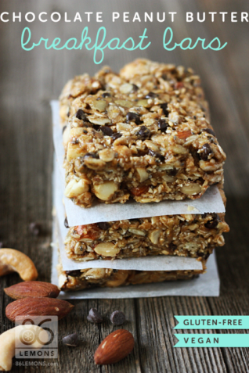
Directions:

Line an 8×8 (or similar size) pan or baking dish with parchment paper. Leave extra on the sides to use as handles for removing the bars later. In a large bowl, combine the oats, flax seed meal, seeds and nuts; mix thoroughly. Add agave nectar to the mixture and stir until well coated. Add peanut butter (or other nut butter) to the mixture and mix until well combined. Scoop the mixture into the prepared pan/baking dish and press firmly until it is evenly distributed. Original recipe instructs to allow mixture to then sit overnight (to firm up) before cutting into bars. I’m not that patient—I put mine in the freezer for an hour or so and it seemed to work just fine. Using the parchment paper handles, remove the entire block from pan/baking dish, then cut into bars. Makes 12-16 bars

Ingredients
1½ cups rolled oats
¼ cup flax seed meal
⅛ cup chia seeds
¼ cup sunflower seeds
¼ cup sesame seeds
⅓ cup pumpkin seeds
½ cup cashews
½ cup almonds
½ cup agave nectar
1 cup natural peanut or almond butter
½ cup chocolate chips
No Bake Quinoa Crumble Bars
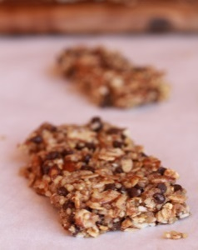

Ingredients:
1 1/4 cups granola (I used original)
1 cup cooked quinoa, cooled
1 cup coarsely chopped raw almonds
1/2 cup ground flaxseed
1/4 teaspoon salt
1/3 cup honey
1/4 cup melted coconut oil or peanut butter
1 teaspoon vanilla extract
3/4 cup mini chocolate chips or dried
pomegranate seeds or a mix

Directions:
In a large bowl, combine quinoa, granola, almonds, flaxseed and salt, stirring to mix well. Fold in chocolate chips and or pomegranate seeds. Stir in honey, coconut butter and vanilla extract, mixing well with a spoon until combined. Place mixture in the microwave for 45 seconds. Allow to cool slightly and pour over dry ingredients mix until entire mixture is moistened. If it still seems too dry, add additional honey 1 tablespoon at a time, but you don't want it to be too wet. Line a 9x9 baking dish with plastic wrap or parchment paper. Firmly press the mixture into the pan, into all the corners and evenly top it off with a spoon. You want it packed as tightly as possible. Refrigerate for at least 2 hours, then remove and lift granola bars out of pan, cutting into 12 squares. These work best refrigerated. Makes 12

Healthy granola bars –kids love it!!
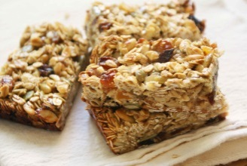

Ingredients:
Try to find ALL Organic Ingredients
2 cup – Raw Oatmeal
1 ½- cup –Natural Peanut Butter
½ tsp – Vanilla extract
½ cup - agave sweetener or raw honey
1T of ground flaxseed and wheat germ
As many tart cherries or raisins as you like

Directions: Mix well with spoon or hands…flatten out between two pieces of wax paper and let sit over night in the fridge… Enjoy

Apricot-Almond Lara-Bars

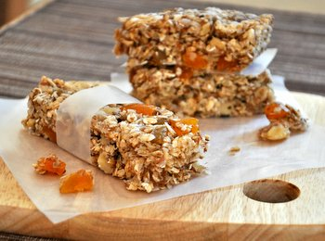
Ingredients:
½ cup almonds, ground in food processor
½ cup apricots, packed
¼ cup dates, packed
¼ cup almonds, roughly chopped
2-3 tbsp oat flour
Pinch of salt
½ tsp cinnamon
¼ tsp vanilla extract

Directions:Grind nuts in food processor, add dried fruit and process until combine, add in rest of ingredients and process until a dough forms. Form into a flat square about 1 ½ inches thick. Cut into bars and store in fridge and eat these on the go! Makes 6-7 bars.
Apricot-Walnut Cereal Bars
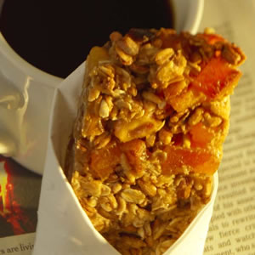

Ingredients:
3 cups old-fashioned rolled oats
1/2 cup chopped walnuts, (about 2 ounces)
3 cups unsweetened puffed-grain cereal, such as Kashi
2 cups chopped dried apricots
1/4 cup all-purpose flour
1/2 teaspoon salt
12 ounces silken tofu, drained (about 1 1/3 cups)
1 large egg
1/2 cup canola oil
1 cup honey
1 tablespoon vanilla extract
2 tablespoons freshly grated lemon zest

Directions: Preheat oven to 350°F. Coat a large (15 1/4-by-10 1/4-inch) jellyroll-style pan with cooking spray. Spread oats and walnuts on a baking sheet with sides. Bake until fragrant and light golden, 8 to 10 minutes. Transfer to a large bowl and add puffed cereal, dried apricots, flour and salt; stir to combine. Meanwhile, puree tofu, egg, oil, honey, vanilla and lemon zest in a food processor or blender until smooth, scraping down the sides as needed. Make a well in the center of the oat mixture; fold in the tofu mixture until combined. Spread evenly in the prepared pan. Bake until firm in the center and golden brown, 35 to 40 minutes. Let cool completely in the pan on a wire rack before cutting into bars with a sharp knife. Makes 16 servings.

No-Bake Granola bars!
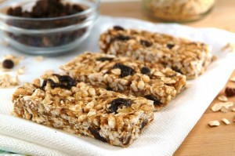
Canola cooking spray
1 tablespoon butter or margarine
1/3 cup Natural peanut butter
2 cups miniature marshmallows, lightly packed
1 cup low-fat granola
~1/3 cup of ground flax seed
1 lg spoonful of wheat germ
1 cup Rice Krispies cereal (or other puffed rice cereal)
Coat an 8 x 8-inch baking pan with canola cooking spray. Put the butter, peanut butter, and marshmallows into a medium-sized microwave safe bowl and microwave on high for 30 seconds, or until mixture is just melted. Stir to blend. Microwave again briefly if the mixture isn't melted or smooth. Then stir in granola, puffed rice and flaxseed. Spread the mixture in the prepared pan, flattening it evenly with a sheet of waxed paper. Let it cool completely before cutting into 8 equal-sized bars.

Pumpkin oat circles
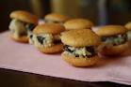
Ingredients:
1 packet of Quaker oats high fiber cinnamon swirl instant oatmeal
1 can of pumpkin
Vanilla wafers

Directions:
Mix 1 packet of oatmeal with desired amount of pumpkin (I use about ½ can). Put some of the mix in between 2 vanilla wafers to make a sandwich. Make desired amount of sandwiches.
Veggie pancakes
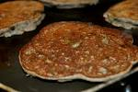
Ingredients:
Your favorite Pancake Mix
Carrots
Zucchini
Directions:
Cook and puree carrots and zucchini (If I’m making a few pancakes I might use 1 whole carrot and ½ zucchini). Prepare pancake mix as directed on the box then add the veggie puree mix. Then cook pancakes as you normally do. Freezes and warms well! PS- you can use any veggie puree as desired.

No Junk Apple, Cinnamon, and Strawberry Muffins
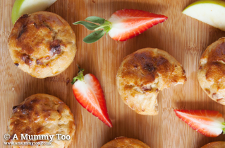

Instructions: Preheat oven to 200°C. Whisk the eggs with the maple syrup, cinnamon and olive oil (or gently melted coconut oil). Grate the apples and stir into the egg mixture with the strawberry pieces. Then fold in the self-rising flour with a metal spoon. Spoon into greaseproof muffin tins, and bake for approximately 20 min, until golden and cooked in the center.

Ingredients:
2 apples
3 eggs
3.5 oz or 2/3 cup unsifted self-rising flour
2 tsp cinnamon
2 tbsp maple syrup
80-120ml olive oil / coconut oil (start with 80ml, add more if mix feels dry)
1.8 oz dried strawberry pieces

Apple-raisin buckwheat muffins
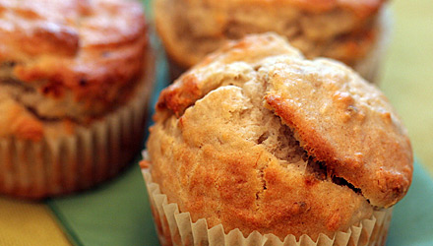

Ingredients:
Olive oil cooking spray
1 cup all-purpose flour
3/4 cup buckwheat flour
2 tablespoons brown sugar
1 1/2 teaspoons baking powder
1/4 teaspoon baking soda
3/4 cup reduced-fat buttermilk
2 tablespoons vegetable oil
1 large egg
1 cup peeled, cored, and diced fresh apples
1/4 cup golden raisins

Directions:
Prepare a muffin tin by lining 12 muffin cups with papers or by spraying each cup with nonstick cooking spray. Preheat oven to 375° F. In a mixing bowl, combine flours, sugar, baking powder, and baking soda. In a separate mixing bowl, combine buttermilk, oil, and egg, and beat until smooth. Add liquid ingredients to dry ingredients and blend only until dry ingredients are moistened. Fold in apples and raisins. Fill muffin cups about 2/3 full. Bake for approximately 20 minutes until golden brown and done through. Muffins are done when a toothpick inserted into one or two muffins comes out clean. Yield: 12 muffins. Serving size: 1 muffin.

Yam and Jam Muffins
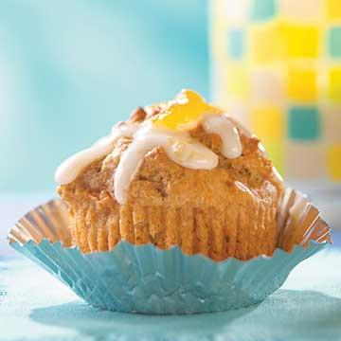

Ingredients:
1 3/4 cups all-purpose flour
1/3 cup packed brown sugar
1 1/2 teaspoons baking powder
1/2 teaspoon baking soda
1 teaspoon apple pie spice or ground cinnamon
1/4 teaspoon salt
1/2of a 17-ounce can sweet potatoes, drained (~ 1 cup)
1 beaten egg
1/2 cup milk
1/3 cup fruit jam or preserves (such as plum, strawberry, peach, or apricot)
1/4 cup veg oil

Directions: Lightly grease twelve 2-1/2-inch muffin cups or line with paper bake cups; set aside. In a large bowl combine flour, brown sugar, baking powder, baking soda, apple pie spice, and salt. Make a well in center of flour mixture; set aside. In another bowl mash the drained sweet potatoes with a fork. Stir in egg, milk, jam, and oil. Add sweet potato mixture all at once to flour mixture. Stir just until moistened (batter should be lumpy). Spoon batter into prepared muffin cups, filling each about three-fourths full. Bake in a 400 degree F oven for 18 to 20 minutes or until golden and a wooden toothpick inserted in centers comes out clean. Cool in muffin cups on a wire rack for 5 minutes. Remove from muffin cups. Cool slightly. Drizzle muffins with Jam Icing and, if desired, top with additional jam or preserves. Makes 12 muffins

Breakfast Blueberry-Oatmeal Cakes
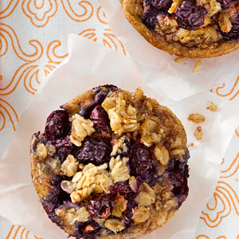

Ingredients:
2 1/2 cups old-fashioned rolled oats
1 1/2 cups low-fat milk
1 large egg, lightly beaten
1/3 cup pure maple syrup
2 tablespoons canola oil
1 teaspoon vanilla extract
1 teaspoon ground cinnamon
1 teaspoon baking powder
3/4 cup blueberries, fresh or frozen

Directions: Combine oats and milk in a large bowl. Cover and let soak in the refrigerator until much of the liquid is absorbed, at least 8 hours and up to 12 hours. Preheat oven to 375°F. Coat a 12-cup nonstick muffin tin with cooking spray. Stir egg, maple syrup, oil, vanilla, cinnamon, and baking powder into the soaked oats until well combined. Divide the mixture among the muffin cups (about 1/4 cup each). Top each with 1 tablespoon blueberries. Bake the oatmeal cakes until they spring back when touched, 25 to 30 minutes. Let cool in the pan for a 10 minutes. Loosen and remove with a paring knife. Makes 6 servings.

Spicy (not that kind of spicy) Sweet Potato Muffins

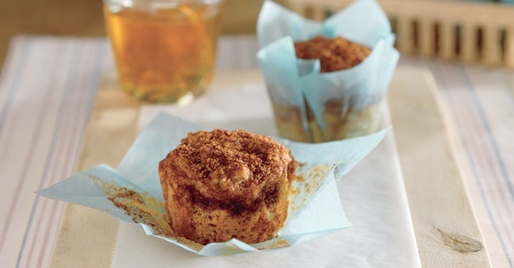

Ingredients:
2 teaspoons ground cinnamon, divided
1 1/2 cups all-purpose flour
2 teaspoons baking powder
1/2 teaspoon salt
1/2 teaspoon baking soda
1/2 teaspoon ground allspice
1 cup mashed cooked or canned sweet potatoes
3/4 cup low-fat buttermilk
1/4 cup vegetable oil
1/3 cup plus 2 tablespoons packed brown sugar, divided
1 egg

Directions:
Preheat oven to 425°F. Spray 12 standard (2 1/2-inch) muffin cups with nonstick cooking spray. Combine 2 tablespoons brown sugar and 1 teaspoon cinnamon in small bowl; mix well. Set aside. Combine flour, baking powder, remaining 1 teaspoon cinnamon, salt, baking soda and allspice in large bowl. Stir in remaining 1/3 cup brown sugar. Combine sweet potatoes, buttermilk, oil and egg in medium bowl; mix well. Stir into flour mixture just until moistened. Spoon evenly into prepared muffin cups. Sprinkle with brown-sugar cinnamon mixture. Bake 14 to 16 minutes or until toothpick inserted into centers comes out clean. Remove to wire rack; cool completely. Yield: 12 muffins. Serving size: 1 muffin.

5 Ingredient Peanut Butter Energy Bites
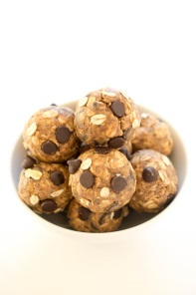
Ingredients
⅔ cup creamy peanut butter
½ cup semi-sweet chocolate chips
1 cup old fashioned oats
½ cup ground flax seeds
2 tablespoons honey

Instructions
Combine all 5 ingredients in a medium bowl. Stir to combine. Place in the refrigerator for 15-30 minutes so they are easier to roll. Roll into 12 bites and store in the fridge for up to a week. Makes 12

Peanut Butter Oat Bites
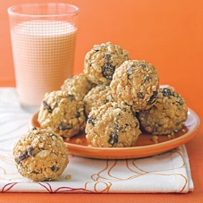

Directions:
Melt butter in a medium saucepan over medium heat. Remove pan from heat and stir in peanut butter, confectioners' sugar, honey and vanilla. Stir in Rice Krispies and oats and allow mixture to cool. Stir in raisins and chocolate chips. Form mixture into 1-inch balls, then roll each ball in chopped peanuts, pressing to coat. Store in refrigerator. Makes 24

Ingredients :
2 tablespoons unsalted butter
2/3 cup creamy natural peanut butter
1/4 cup confectioners' sugar
3 tablespoons honey
1 teaspoon vanilla extract
1 1/2 cups Rice Krispies cereal
1 cup quick oats
1/4 cup raisins
1/4 cup mini chocolate chips
1/4 cup finely chopped lightly salted dry-roasted peanuts

Date Balls
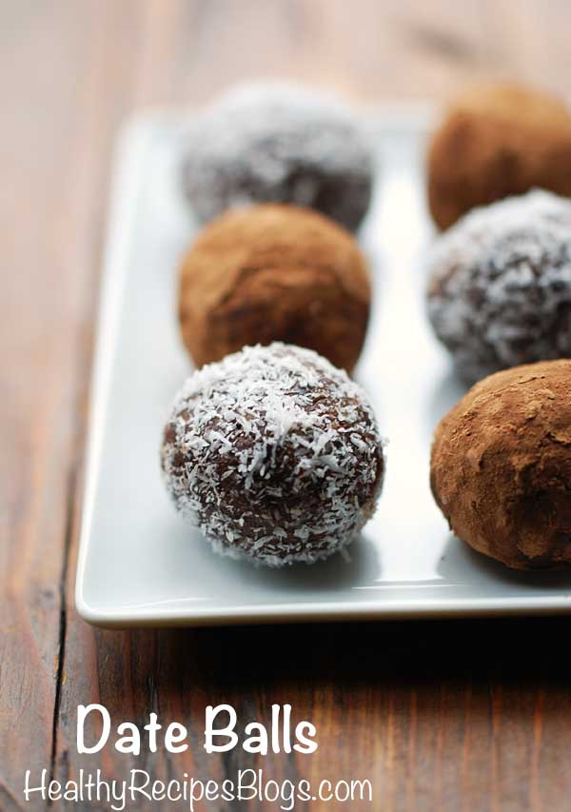

Ingredients
15 dates (10 oz), pitted
½ cup almond butter (I used Justin’s classic almond butter)
½ cup unsweetened cocoa powder
1 teaspoon pure vanilla extract
1 teaspoon ground cinnamon

Topping (optional):
1 tablespoon unsweetened cocoa powder
1 tablespoon unsweetened shredded coconut
Track Your Plaque Psoriasis Symptoms

Directions
Place the dates, almond butter, cocoa powder, vanilla and cinnamon in your food processor bowl. Process until the ingredients come together into rough dough. Remove the dough from the food processor and shortly knead it with clean hands. Divide into 16 balls, each weighing 1 oz. Roll the balls in the toppings. Arrange the date balls on a tray or a baking sheet. Refrigerate for 1 hour, to allow them to set and flavors to meld. Store leftovers in an airtight container in the fridge. Remove from fridge 10 minutes before serving. Makes 16 balls

No Bake Breakfast Cookies

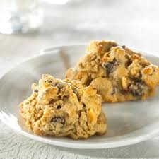

Ingredients
1/2 cup honey (or light corn syrup)
1/2 cup nonfat dry milk (instant)
1/2 cup raisins (or chopped dates)
1/2 cup creamy peanut butter
2 1/2 cups flaked cereal (coarsely crushed)

Instructions
Heat honey and peanut butter in a medium saucepan over low heat. Stir until
blended. Remove from heat. Stir in dry milk. Fold in cereal and raisins. Drop by heaping Tablespoons onto waxed paper to form mounds. Cool to room temperature. Store in refrigerator. Makes 12, serving size is 2, 2 ½ cookies

3-Ingredient Banana Bread Cookies
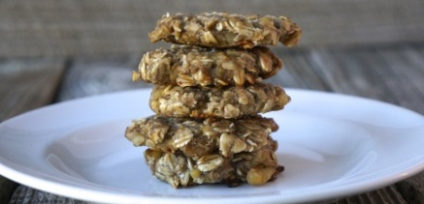

Ingredients
2 bananas
1 cup rolled oats
1/4 cup chopped walnuts
cooking spray

Directions
Pre-heat oven to 375 degrees F. Mash bananas thoroughly. Mix in oats & walnuts.
Mist baking sheet with cooking spray. Using a scoop, form 16 cookies on sheet.
Bake for 18-20 minutes. Immediately after removing cookies from over, press them flat with the bottom of a small drinking glass. Allow to cool. Freeze or store cookies in an airtight container for up to 5 days. Serves 16

Cupid Clusters

Ingredients
3 cups Yogurt-Burst Cheerios or similar whole-grain cereal
1/2 cup chopped dried strawberries
1 1/2 cups white chocolate chips

Make It
Place paper liners in 24 mini muffin cups. Toss the whole-grain cereal and chopped dried strawberries in a medium bowl. Melt the white chocolate in a microwave on high for a minute, stirring it frequently. Combine with the cereal and strawberry mixture. Spoon into prepared cups and refrigerate until the clusters are firm, about 5 minutes. Makes 24 clusters

Fiesta Mix
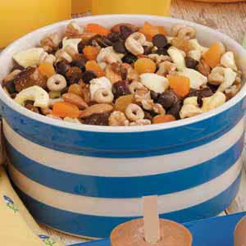
Ingredients
1 cup cereal with fruit
1 cup "chex" type bran cereal
1 cup "O" type cereal
1/4 cup raisins
1/4 cup peanuts
1/4 cup shredded coconut

Instructions
Mix cereals together in a large bowl. Add raisins, peanuts, and coconut; mix well. Eat it dry or with milk. Makes 4 servings, ¼ of recipes

Crunch-Crunch-Crunch Mix
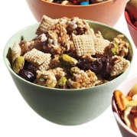
1/2 cup dried cherries, 2 cups whole-grain Rice Chex, 1/2 cup roasted unsalted pistachios, 3 cups Kashi Go Lean Crunch Cereal

Trail mix ideas:
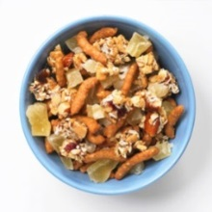
-Sesame sticks + chopped cereal-nut bars + dried pineapple
-Mini pretzels twists + cashews + dried cranberries
-Mini pita chips + soy nuts + mini chocolate chips
-Low-fat granola + sunflower seeds + dried apricots
-Dried papaya + whole-grain cereal + golden raisins

Real-Fruit Rolls
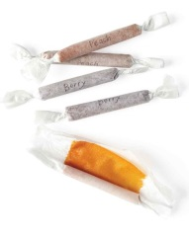

Ingredients
4 cups berries or chopped stone fruit
1/2 cup sugar
1 tablespoon fresh lemon juice

Directions
Puree berries or chopped stone fruit, sugar, and lemon juice. Cook in a saucepan over medium heat until thick, 30 to 35 minutes. Strain through a fine sieve onto a baking sheet lined with a nonstick baking mat; tilt to distribute. (Use a pan that isn't warped to prevent pooling.) Bake at 170 degrees until dehydrated, 2 1/2 to 3 hours. Let cool for 10 minutes. Cut into eight 4 1/2-by-5 1/2-inch rectangles. Roll in parchment. store at room temperature for up to 1 month -- or 2 seconds, depending on your kids' appetites.

Fruit Leather Roll-Ups
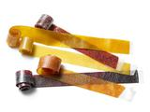

Ingredients
1 1/4 pounds chopped fruit (see below for suggested flavors)
3/4 cup sugar
1 to 2 tablespoons fresh lemon juice

Directions
Preheat the oven to 200 degrees F. Combine the fruit and sugar in a blender. Add the lemon juice to taste (use 2 tablespoons for apples or bananas) and puree until smooth.
Transfer the pureed fruit to a medium saucepan and bring to a simmer over medium-high heat. Reduce the heat to medium low and cook, stirring occasionally at first and then more often toward the end, until most of the liquid evaporates and the mixture is very thick, 35 to 45 minutes. Be careful: The mixture may splatter. Line a 12-by-17-inch rimmed baking sheet with a silicone mat or nonstick foil. Use an offset spatula to spread the fruit on the mat or foil into a thin layer. Bake until barely tacky, 3 hours to 3 hours, 30 minutes. Transfer the baking sheet to a rack and let the fruit leather cool completely. Peel off of the mat or foil. If the leather is still moist on the underside, return it to the oven, moist-side up, until dry, about 20 more minutes. Lay the leather smooth-side down on a sheet of wax paper and use kitchen shears to cut it into strips on the paper. Roll up the strips and store in zip-top bags for up to 1 week.

Plum: 5 medium, unpeeled, chopped
Peach or nectarine: 5 medium, unpeeled, chopped
Apple: 3 large (Gala or Granny Smith), peeled and chopped
Strawberry: 4 cups, hulled and chopped
Raspberry: 5 cups
Grape: 3 1/2 cups (preferably Concord), seeded if necessary
Banana: 5 medium, peeled
Mango: 2 large, peeled and chopped
Raspberry-Vanilla: 5 cups raspberries plus the seeds from 1/2 vanilla bean
Strawberry-Banana: 3 cups strawberries, hulled and chopped, plus 2 medium bananas, peeled
Apple-Ginger: 3 large apples, peeled and chopped, plus 1 1/2 teaspoons grated ginger
Spicy Mango: 2 large mangoes, peeled and chopped, plus 1/8 teaspoon each salt and cayenne pepper

Autumnal Fruit Leathers
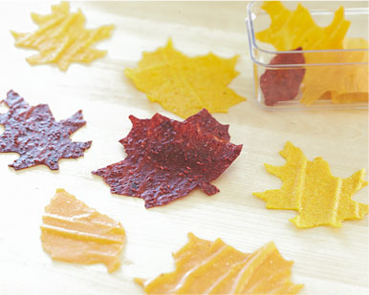
Skip cookies and candy and try this naturally sweet, autumn-inspired fruit leather for a special treat. Have fun with different cookie-cutter shapes and
fruits to fit the season.

Ingredients
Fruits of your choice, dried, fresh or frozen. For autumnal colors, we suggest, strawberries, bananas, apricots and oranges.

Directions
Warm the fruit in a pot on the stove and mix it into a puree. Spread the puree on oil-sprayed parchment paper. Place in the oven at 140° (or as low as your oven can go). Leave the oven door open a bit to let the moisture out. The leathers are done when the puree isn't sticky anymore – usually 5-8 hours, depending on the oven and which fruit you're using. Use a sharp knife, pizza cutter or cookie cutters to cut them. Roll them with wax or parchment paper when they're still warm. Add a dash of cinnamon or vanilla if desired.

Strawberry Oatmeal Bars
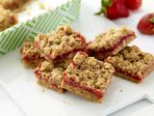

Ingredients
1 3/4 sticks salted butter, cut into pieces, plus more for greasing pan
1 1/2 cups all-purpose flour
1 1/2 cup oats
1 cup packed brown sugar
1 teaspoon baking powder
1/2 teaspoon salt
One 10 to 12-ounce jar strawberry preserves

Directions
Preheat the oven to 350 degrees F. Butter a 9-by-13-inch rectangular pan.
Mix together the butter, flour, oats, brown sugar, baking powder and salt. Press half the oat mixture into the prepared pan. Spread with the strawberry preserves. Sprinkle the other half of the oat mixture over the top and pat lightly. Bake until light brown, 30 to 40 minutes. Let cool completely, and then cut into squares.
Per serving: Calories: 177; Total Fat: 7 grams; Saturated Fat: 4 grams; Protein: 2 grams; Total carbohydrates: 28 grams; Sugar: 18 gram; Fiber: 1 gram; Cholesterol: 18 milligrams; Sodium: 72 milligrams

Sweet-Potato Chips
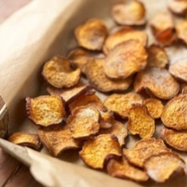

Ingredients
2 medium sweet potatoes
2 teaspoons vegetable oil
1 teaspoon sugar
1/2 teaspoon cinnamon

Make It
Heat oven to 400 degrees F. Coat a baking sheet with vegetable cooking spray. Wash potatoes. Cut into thin slices, and place in large bowl. Pour oil onto the palms of your hands. Gently rub oil onto sweet-potato slices, tossing to combine. Sprinkle with sugar and cinnamon, tossing in bowl to coat evenly. 3. Place slices in a single layer on prepared baking sheet. Bake 20 minutes. Turn chips over and bake until slightly crisp, about 5 minutes. Transfer to plate; cool 5 minutes and serve. Makes ~70 chips

Veggie Chips
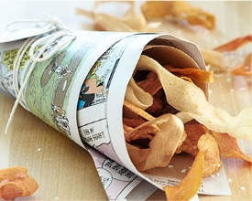
For a consistent, thin shape, use a vegetable peeler when making these delicious, crunchy snacks. Do away with potato chips and try these light, colorful crisps instead.

Ingredients
2 large carrots
2 large zucchinis
Olive oil
Salt to taste

Directions
Peel carrots and zucchinis. Once peeled, use peeler to peel away long strips of each vegetable. Pour vegetable oil in a large saucepan. Heat to medium heat (about 375°).
Add a few vegetable strips at a time to the oil and fry until lightly crisp, about 1 to 2 minutes. Remove vegetable strips and place on a paper towel to remove excess oil.
Sprinkle with salt to taste. Serve immediately.

Apple Chips
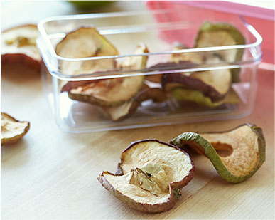
Bake a few apple slices for a delicious after-school snack – or as a nutritious alternative to regular store-bought chips. They're easy to make, and they store well. If your kids love chips, this recipe offers a perfect healthy twist. For variety, try firm pears or persimmons.

Ingredients
1-2 apples

Directions
Heat oven to 225 degrees F. Slice apples horizontally through the center; remove seeds.
Bake apple slices on parchment-lined baking sheets for 1– 1 1/2 hours. Turn them over and continue to bake for another hour, or until crisp. Remove and let cool.
Sprinkle cinnamon on top for an extra-special treat.

Chewy Apple chips
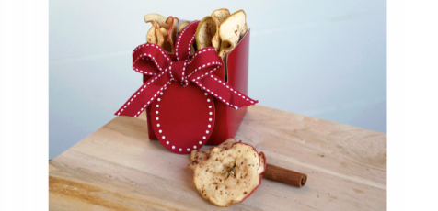

Ingredients
2 large apples (rec. Granny Smith or Honeycrisp)
2 teaspoons apple pie spice or cinnamon

Directions
Preheat oven to 250 degrees F. Carefully slice apples, width-wise, into 1/8" disks. Tip: Use a mandolin for uniform slices. Each apple makes about 16 slices. Line 2 baking sheets with parchment paper and arrange apple slices in a single layer. Sprinkle with apple pie spice or cinnamon. Bake for 50 minutes. Flip apples over and bake an additional 50 minutes or until crispy. Remove from oven and allow to cool completely. Store at room temperature in an air tight container for up to 7 days. Note: They will be crisp after you take them out of the oven for 1-2 hours. They turn deliciously chewy afterwards. https://dawnjacksonblatner.com/recipes/chewy-apple-chips/. Serves 32

Plantain Chips
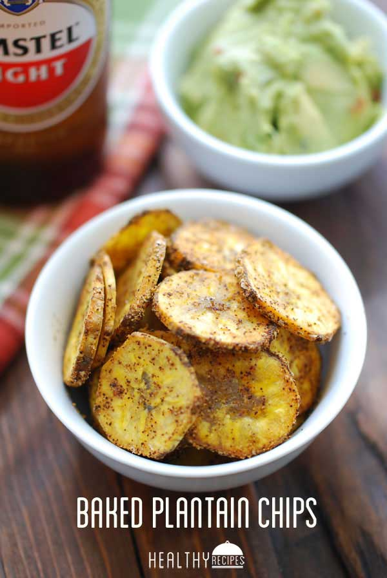

Ingredients
1 green plantain (6 oz)
1 tablespoon extra-virgin olive oil
½ teaspoon kosher salt
½ teaspoon chili powder
¼ teaspoon garlic powder
¼ teaspoon cumin
⅛ teaspoon cayenne pepper

Directions
Preheat oven to 400 degrees F. Line a cookie sheet with parchment paper.
Cut the ends of the plantain, then peel it with a paring knife (plantains do not peel as easily as bananas, hence the need to use a knife). Slice the plantain as thinly and uniformly as you can (use a mandoline if you have one). Most recipes tell you to slice them on the diagonal, but I like them round. In a small bowl, toss the plantain slices with the olive oil and seasonings. Spread in a single layer on the prepared cookie sheet. Bake 8-10 minutes per side, or until browned and crispy on both sides. Serve immediately – plantain chips lose their crispness after a few hours. 2 Servings

Pear/apple chips
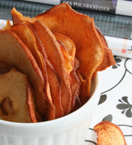

Ingredients:
2 apples, 2 pears

Directions:
Preheat oven to 250 degrees. Using a mandoline, thinly slice the apple and pears into “chips” (you can also cut them with a knife into thin slices if you don’t have one). Place the slices on a parchment lined baking sheet (do not overlap the pieces). Bake for 1 hour, turning the “chips” halfway through (if you live in a humid climate, they may take a bit longer). Cool and serve.

Everything Bagel Chips
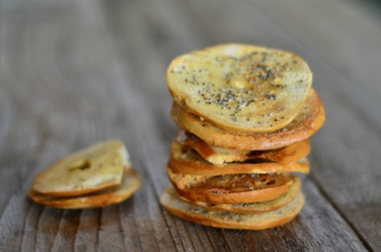
Ingredients
6 mini bagels
3 tablespoons olive oil
1/2 teaspoon kosher salt
1/2 teaspoon poppy seeds
1/2 teaspoon sesame seeds
1/2 teaspoon dried minced garlic
1/2 teaspoon dried minced onion

Instructions
Preheat oven to 350F degrees. Place everything except bagels and olive oil into a small bowl. Slice bagels as thinly as you can. I cut each half into thirds. Line bagel thins on a baking sheet. Drizzle with olive oil and sprinkle with everything seasoning mix.
Bake for 15 minutes, rotating the pan halfway through. Remove from oven and let cool before storing at room temperature up to a week.

Bagel Chips
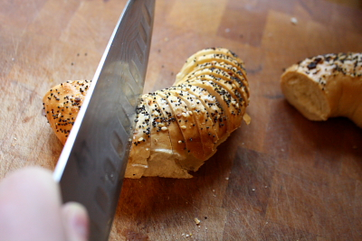
Ingredients:
2 Everything bagels
Olive oil spray
1/2 teaspoon garlic powder

Directions:
Preheat oven to 350 degrees Fahrenheit. Slice the bagel in half from the top down, not from the side as one usually does for toasting and serving. Slice each bagel half into 1/8 to 1/4-inch thick rounds. Lay the rounds on two baking sheets in a single layer. Spray lightly with olive oil. Sprinkle the garlic powder over the rounds. Bake for 8-10 minutes or until golden and crispy. Allow to cool on the baking sheet before serving. Store in an airtight container. Makes 3 cups

Other simple ideas:
Air popped popcorn - Perk it up with a bit of lemon pepper and Parmesan cheese.
Trail mix Raisins
Nuts Pretzels
Dried fruit Goldfish

http://sweetcsdesigns.com/easy-baked-sweet-potato-chips/

http://www.tastespotting.com/features/roasted-edamame-recipe-canyon-ranch

http://www.tablefortwoblog.com/zucchini-chips/ or this recipe http://sugarapron.com/2014/06/16/baked-zucchini-chips-recipe/2/
http://amyshealthybaking.com/blog/2015/01/03/apple-pie-oatmeal-cookies/
http://mixedgreensblog.com/2013/01/27/seasons-eatings/appetizers/homemade-chips-for-the-couch-potato-in-all-of-us/

